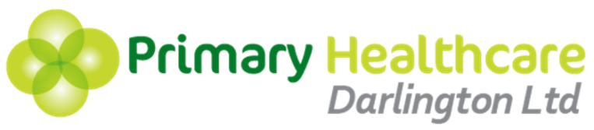

Contraception & Sexual Health Service (CASH)
Clinic Details

Please find below details of the CASH clinics to be provided from 1st September 2016.
To book an appointment, please ask patients to telephone the CASH clinic on 01325 952277.
Clinic | Services | Time & Venue
College Clinic  (Open to college students only) | Emergency Contraception  C-Card  Implanons  Contraception Advice  Chlamydia and gonorrhoea screening  Contraception (pill, patch, Depo)  Pregnancy testing | Monday  9.30am – 1.00pm  (term time only)  Darlington College  Haughton Road
Young People’s Clinic  (13-25 years only) | Emergency Contraception  C-Card  Implanons  IUS/IUD  Contraception Advice  Chlamydia and gonorrhoea screening  Contraception (pill, patch, Depo)  Pregnancy testing | Tuesday  4pm – 7.30pm  Denmark Street Surgery
Evening Clinic  (13 years+) | Emergency Contraception  C-Card  Implanons  IUS/IUD  Contraception Advice  Chlamydia and gonorrhoea screening (under 25s only)  Contraception (pill, patch, Depo)  Pregnancy testing  Complex contraceptive problems | Wednesday & Thursday  4pm – 7.30pm  Denmark Street Surgery
Weekend Clinic  (13 years+) | Emergency Contraception  C-Card  Implanons  IUS/IUD  Contraception Advice  Chlamydia and gonorrhoea screening (under 25s only)  Contraception (pill, patch, Depo)  Pregnancy testing  Complex contraceptive problems | Saturday  9.30am – 1.00pm  Denmark Street Surgery

