
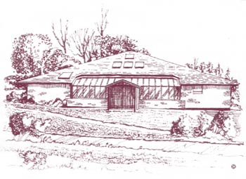Carmel Medical Practice
Patient Participation Group
Date: Thursday 8th February

Present:
Terri Bartlett – Practice Manager
Rachel Morris – Office Manager
Sheila Crosby
Sheila Parkes
Richard Twomey
Neil Thompson
Michael Bennett

Item | Outcome | Action
Apologies For Absence | Bruce Elliott, Carole Ferguson
Minutes of Last Meeting | N/A
Matters Arising | N/A
Agenda Items  New Patient Questionnaire  Clinical Pharmacist Bid  AOB | We now have a new patient questionnaire which will be used by ourselves and within our hub practices. It hasn’t been rolled out to all 11 practices within Darlington but hopefully in the future it will be. It will be updated / reviewed periodically. (New Patient Questionnaire attached)  The Practice Managers for each hub attend regular two monthly meetings for updates. At the moment there is community based events in Darlington lined up within the hub and Terri will keep you posted when these have been organised.  NHS England have launched and funded a clinical pharmacist pilot for general practices. Our hub have submitted a bid on 19th January, if we are successful the clinical pharmacist would be shared across our hub practices on a full time basis. Moorlands Surgery already has a full time clinical pharmacist so they haven’t joined in on the bid as they have no need to.  A clinical pharmacist would be extremely beneficial; they specialise in medication and would help with the work load GP’s face on a daily basis. They can help with medication reviews, medication advice and help meet prescribing targets. As part of the agreement the clinical pharmacist would be employed on a permanent basis at the end of the pilot. (See attachment for more information on Clinical Pharmacists)  The appointment system is available to be pre-booked a few days in advance. On a Monday there are appointments open and available to be booked for each day of the week but they do tend to be booked very quickly due to high demand. Online booking is also available and easy to use. We do have emergency appointments and don’t refuse patients. | Terri will update at next meeting at the status of the bid.
Next Meeting | 19th April 2018

