PROFESSOR A FUAT DR A MULLENHEIM DR M RANDALL  DR H RAZA DR G GEDDES | CARMEL MEDICAL PRACTICE  NUNNERY LANE DARLINGTON  DL3 8SQ  Telephone: (01325) 520794 Email:nencicb-tv.a83081-  eds@nhs.net

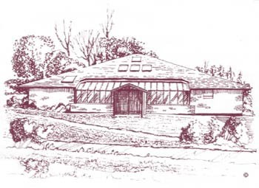
Patient Complaint Form – Third Party Consent Form

Patient Details: _____________________________________________________________
Patient’s Full Name _____________________________________________________________
Date of Birth Address _______________________________________________________________________
____________________________________________________________________________
____________________________________________________________________________
_____________________________________________________________________________
Telephone Number Enquirer / Complainant Details:
Full Name
Relationship to Patient Address_____________________________________________________________________
____________________________________________________________________________
_____________________________________________________________________________

Telephone Number

If you are complaining on behalf of a patient or your complaint or enquiry involves the medical care of another patient then the consent of the patient will be required. Please obtain the patient’s signed consent below.

I fully consent to my Doctor releasing information to, and discussing my care and medical records with, the person named above.
This authority is for an indefinite period / for a limited period only (delete as appropriate). Where a limited period applies, this authority is valid until (insert date)

Signed (Patient) Date

