|  |  |
| --- | --- |
| **PROF A FUAT**  **DR E MOORE**  **DR C MARKWICK**  **DR A ROSS**  **DR L WILSON**  **DR G GEDDES** | **CARMEL MEDICAL PRACTICE**  **NUNNERY LANE**  **DARLINGTON**  **CO DURHAM**  **DL3 8SQ**  **Telephone: (01325) 520794**  **Facsimile: (01325) 381834** |

**Registration Application**

Please be aware that we require the following identification before we are able to register you.

1. Photo ID or birth certificate.
2. Proof of address - this must be a utility bill or bank statement showing your registered address - WE DO NOT ACCEPT COPIES OF TENANCY AGREEMENTS.

Once you have completed the registration forms, please return to our Reception and ask who will be your Registered GP.

**Zero Tolerance Policy**

The Practice takes it very seriously if a member of staff, a Doctor or a member or our Nursing Team are treated in an abusive or violent manner.

The Practice supports the Government’s **‘Zero Tolerance’** campaign for Health Service Staff. This states that GP’s and their staff have the right to care for others without fear of being attacked or abused.

To successfully provide these services, a mutual respect between all the staff and patients has to be in place. All our staff aim to be polite, helpful and sensitive to patient’s individual needs and circumstances. They would respectfully remind patients that very often staff can be confronted with a multitude of varying and sometimes difficult tasks and situations, all at the same time.

Our staff understand that patients who are unwell do not always act in a reasonable manner and will take this into consideration when trying to deal with a misunderstanding or complaint.

However, aggressive behaviour, be it violent or abusive, will not be tolerated and may result in you being removed from the Practice list and, in extreme cases, the Police being contacted.

In order for the Practice to maintain good relations with their patients, the Practice would like to ask all patients to read and take note of the types of behaviour which would be deemed unacceptable:

* Using foul language, or verbally abusing staff
* Any physical violence towards any member of the Practice Team or other patients
* Racial abuse
* Sexual harassment
* Persistent or unrealistic demands which cause stress to staff. Requests will be met wherever possible and an explanation will be given where not.
* Causing damage or stealing
* Obtaining medications and/or medical services fraudulently

We ask you to treat your Gp’s and their staff with courtesy at all times.

**New Patient Questionnaire**

Title: ………………… Name: ………………………………………………………………..………………D.O.B: ……….……………….

Address:…………………………………………………………………………………………………………………………………………….…………………………………………………………………………………………………Postcode:…………………………………………

Telephone No: ………………………………………………Mobile No: ………………………………………………

Email Address: ……………………………………………………………………………………………

Next of Kin: Name: ………………………………………………………………………………………………………………

Telephone No: ……………………………………………………Relationship: ……………………………………………………

Thank you for you cooperation.

Patient Name: ………………………………………………………………………………………………

Signature: …………………………………………………………………… Date: ……………………………………

Do you drink alcohol? Teetotal  Yes  Please complete the questionnaire below

Are you a: Current Smoker  Ex Smoker  Never Smoked  If you are a current smoker, do you smoke: Cigarettes  per day. Cigars  per day. Pipe  gm per week .

Should you wish to stop smoking please contact the surgery for details.

**Medical History:**

Height: ……………………………………………… Weight: …………………………………

Do any of the following diagnoses apply to you? Stroke  Heart Attack  High Blood Pressure  Diabetes Type 1  Diabetes type 2  Epilepsy  Glaucoma  High Cholesterol  Asthma  Chronic Obstructive Pulmonary Disease  Cancer  Please specify………………………………………….. Other  Please specify……………………………………..

Do you have any communication needs relating to a disability or sensory loss? Please specify………………………………………………………………………………………………………

Are you allergic or sensitive to any medicines, food or materials? ………………………………………………………………..

**Ethnicity:** White British White Irish  Other White Background  White/Black Caribbean  White/Black African  White/Black Asian  Other Mixed Background  Black Caribbean  Black African  Indian  Pakistani  Bengali  Other Asian Background  Other  Please specify…………...…………

What is your first Language? ………………………………………………Do you require an interpreter? Yes  No 

How long have you been resident in the UK? From Birth  Other  Please specify……………………………………….

Are you a Carer? Yes  No  Do you have a Carer? Yes  No 

If yes please give you carers name and contact telephone number:

Name: ………………………………………………………………………………………………………………………………………………

Telephone No:…………………………………………………………………

**Family History:**

Do any of the following diagnoses apply to a member of your family? If yes please specify whom and age at onset.

Stroke  Heart Attack  High Blood Pressure  Diabetes Type 1  Diabetes type 2  Epilepsy  Glaucoma  High Cholesterol  Asthma  Chronic Obstructive Pulmonary Disease  Cancer  Please specify………………………………………….. Other  Please specify……………………………………..

Relative:…………………………………………………………………………………………… Age of onset:……………………………

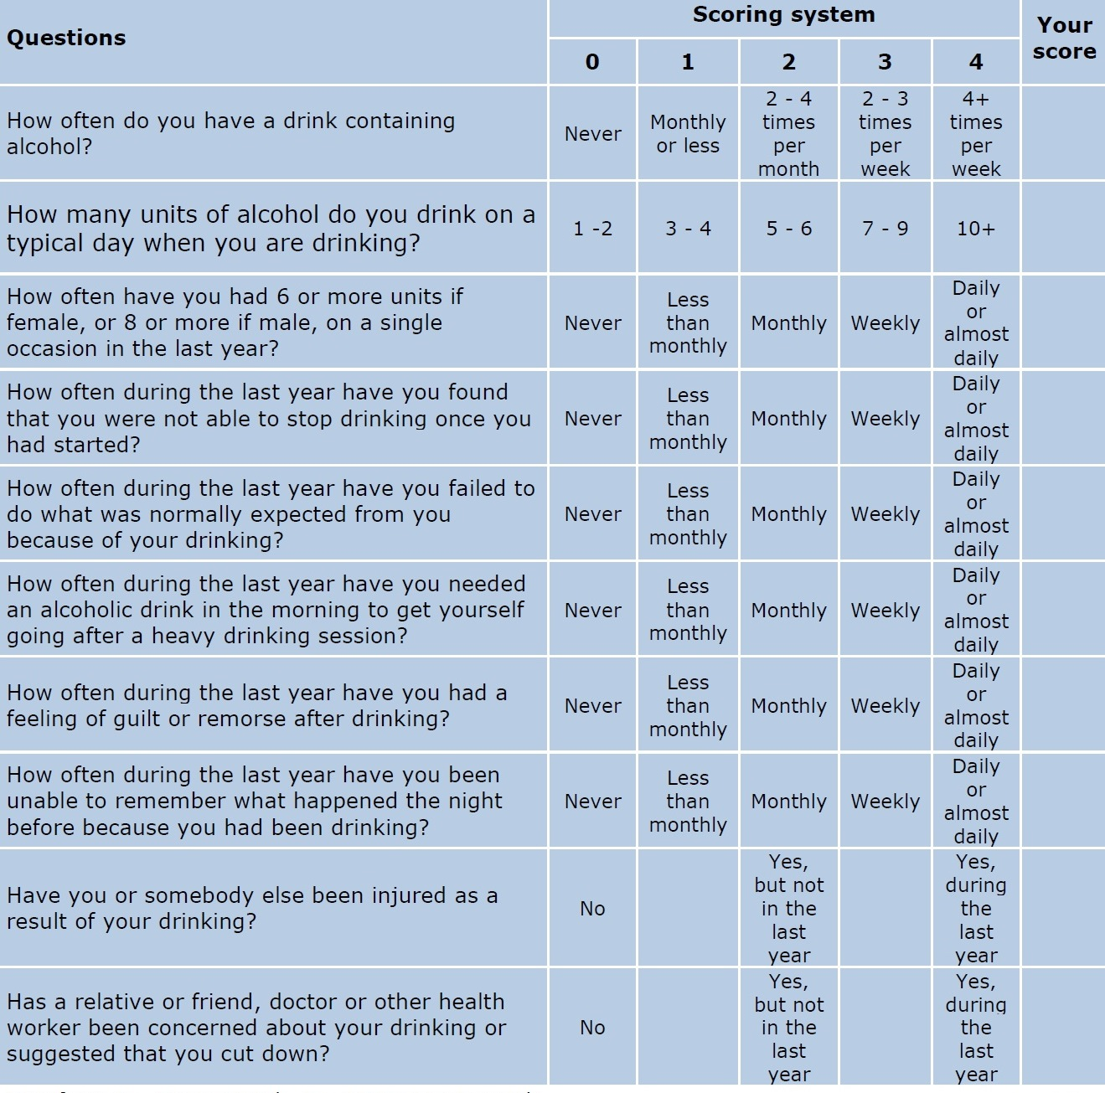

**Pharmacy Nomination:**

If you wish, you can nominate a local pharmacy to receive and dispense you prescriptions.

Please specify the pharmacy of your choice: …………………………………………………………………………

**Information for new patients: about your Summary Care Record**

If you are registered with a GP practice in England, you will already have a Summary Care Record (SCR), unless you have previously chosen not to have one. It will contain key information about the medicines you are taking, allergies you suffer from and any adverse reactions to medicines you have had in the past.

Information about your healthcare may not be routinely shared across different healthcare organisations and systems. You may need to be treated by health and care professionals who do not know your medical history. Essential details about your healthcare can be difficult to remember, particularly when you are unwell or have complex care needs.

Having a Summary Care Record can help by providing healthcare staff treating you with vital information from your health record. This will help the staff involved in your care make better and safer decisions about how best to treat you.

**You have a choice**

You have the choice of what information you would like to share and with whom. Authorised healthcare staff can only view your SCR with your permission. The information shared will solely be used for the benefit of your care.

Your options are outlined below; please indicate your choice on the form overleaf.

* **Express consent for medication, allergies and adverse reactions only.** You wish to share information about medication, allergies for adverse reactions only.
* **Express consent for medication, allergies, adverse reactions and additional information.** You wish to share information about medication, allergies for adverse reactions and further medical information that includes: your illnesses and health problems, operations and vaccinations you have had in the past, how you would like to be treated (such as where you would prefer to receive care), what support you might need and who should be contacted for more information about you.
* **Express dissent for Summary Care Record (opt out).** Select this option, if you **DO NOT** want any information shared with other healthcare professionals involved in your care.

If you chose not to complete this consent form, a core Summary Care Record (SCR) **will** be created for you, which will contain only medications, allergies and adverse reactions.

Once you have completed the consent form, please return it to your GP practice.

You are free to change your decision at any time by informing your GP practice. Copyright © 2017Health and Social Care Information Centre. The Health and Social Care Information Centre is a non-departmental body created by statute, also known as NHS Digital.

**Summary Care Record patient consent form**

Having read the above information regarding your choices, please choose **one** of the options below and return the completed form to your GP practice:

**Yes – I would like a Summary Care Record**

* Express consent for medication, allergies and adverse reactions only.

**or**

* Express consent for medication, allergies, adverse reactions and additional information.

**No – I would not like a Summary Care Record**

* Express dissent for Summary Care Record (opt out).

Name of patient: ………………………………………………..….........................

Date of birth: …………………………… Patient’s postcode: …………………

Surgery name: …………………………… Surgery location (Town): ………..................

NHS number (if known): …………………………..………………...................................

Signature: ……………………………. Date: ………………………………

If you are filling out this form on behalf of another person, please ensure that you fill out their details above; you sign the form above and provide your details below:

Name: ………….........................................................................................................

**Patient Online - Patient registration form**

If you would like to register for this online service please complete the form below and return it to your practice in person, **along with a valid form of identification, for example photo ID or your passport.**  Once you are registered the practice will give you the information that will enable you to create a username and password within 7 days.

**I wish to have access to the following online services (tick all that apply)**

1 Booking appointments

2 Requesting repeat prescriptions

3 Access to my summary medical record

4 Access to detailed coded information

I have read and understood the information leaflet provided by the practice. I will be responsible for the security of the information that I see or download. If I choose to share my information with anyone else, this is at my own risk. I will contact the practice as soon as possible if I suspect that my account has been accessed by someone without my agreement. If I see information in my record that is not about myself or is inaccurate I will log out immediately and contact the practice as soon as possible. I understand that I may request access to read coded information.

|  |  |  |  |  |  |  |  |  |  |  |  |  |  |  |  |  |  |  |  |  |
| --- | --- | --- | --- | --- | --- | --- | --- | --- | --- | --- | --- | --- | --- | --- | --- | --- | --- | --- | --- | --- |
| **Patient details** | **Please complete in BLOCK CAPITALS** | | | | | | | | | | | | | | | | | | | |
| Patient forename |  |  |  |  |  |  |  |  |  |  |  |  |  |  |  |  |  |  |  |  |
| Patient surname |  |  |  |  |  |  |  |  |  |  |  |  |  |  |  |  |  |  |  |  |
| Date of birth | D | D | / | M | M | / | Y | Y | Y | Y |  | | | | | | | | | |
| Email address |  |  |  |  |  |  |  |  |  |  |  |  |  |  |  |  |  |  |  |  |
|  |  |  |  |  |  |  |  |  |  |  |  |  |  |  |  |  |  |  |  |
| Mobile number |  |  |  |  |  |  |  |  |  |  |  |  | | | | | | | | |

|  |  |  |  |  |  |  |  |  |  |  |  |  |  |  |  |  |  |  |  |  |
| --- | --- | --- | --- | --- | --- | --- | --- | --- | --- | --- | --- | --- | --- | --- | --- | --- | --- | --- | --- | --- |
| **Please sign and date** | **(Complete your details below if you are representing a child etc.)** | | | | | | | | | | | | | | | | | | | |
| Parent etc. first name |  |  |  |  |  |  |  |  |  |  |  |  |  |  |  |  |  |  |  |  |
| Parent etc. surname |  |  |  |  |  |  |  |  |  |  |  |  |  |  |  |  |  |  |  |  |
| Relationship to patient |  | | | | | | | | | | | | | | | | | | | |
| Signature |  | | | | | | | | | | | | | | | | | | | |
| Date | D | D | / | M | M | / | Y | Y | Y | Y |  | | | | | | | | | |

|  |  |  |  |
| --- | --- | --- | --- |
| **Staff use only** | **Patient ID seen** | **Type of ID** | **Staff Name/Date** |
|  |  |  |  |

**Consent for use of SMS TEXTING**

The Practice may wish to contact you by SMS Texting to remind you about a forthcoming appointment.

•I agree to the Practice communicating with me by Short Messaging Service (SMS

or Text)

•I confirm that the mobile number the Practice holds on my record is correct and

I will notify them of any changes.

•I agree to receive a reminder of my appointment by SMS.

•I am aware that I can withdraw consent at any time by informing the Receptionist either verbally or in writing.

Name...................................................................................................

Signature..............................................................................................

