CORONAVIRUS PATIENT FREQUENTLY ASKED QUESTIONS
I am self-isolating – do I need a fit note?
You can self-certify for the first seven days. If you are self-isolating for 14 days it is up to your employer to decide what evidence they require, if any, this does not need to be a fit note issued by your GP. If a fit note is required please email your GP practice or complete an e-consult via your practice web-site.

What is best way to request a non-urgent appointment?
Go to your practice web-site and click on the e-consult button and complete the request form. You do not need logon details to use this service – you will receive a response within two days.
I am struggling to buy paracetamol can my GP issue me a prescription?
Unfortunately your GP can only prescribe paracetamol if it is a medication you receive on repeat basis

How do I get my repeat medication?
Please use e-consult from your GP practice web-site or email your GP practice who will arrange to send your prescription to your usual pharmacy or if you do not have a regular pharmacy will post the prescription to your home address.

If I suspect I have Coronavirus can I take ibuprofen?
Guidance suggests that anyone who suspects they have Coronavirus should avoid using anti-inflammatory medication while they are unwell – this includes ibuprofen, naproxen and diclofenac.

If have been advise to follow social distancing – what does that mean?

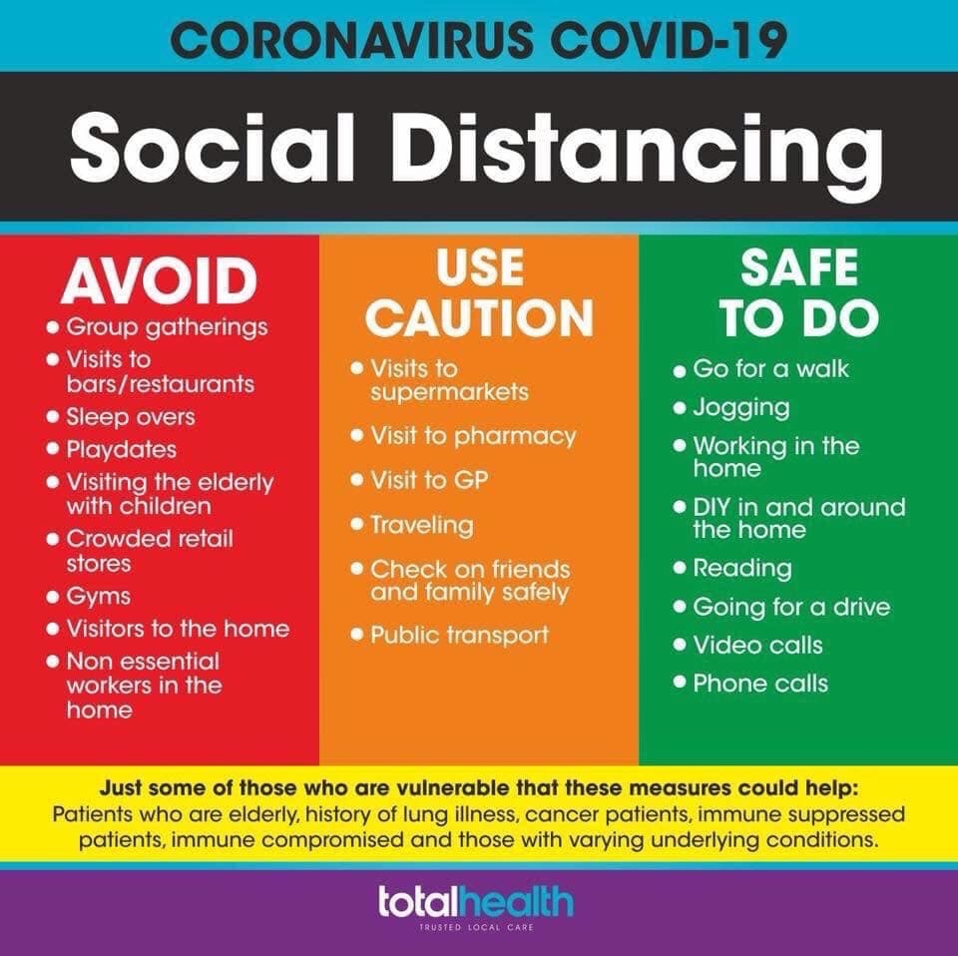
USEFUL PATIENT LINKS

General NHS advice
https://www.nhs.uk/conditions/coronavirus-covid-19/

Pituitary/ adrenal insufficiency (including steroid sick day rules)
https://www.endocrinology.org/news/item/14050/Coronavirus-advice-statement-for-patients-with-adrenal%2fpituitary-insufficiency

Underlying lung disease (British Lung Foundation)
https://www.blf.org.uk/support-for-you/coronavirus

People with Asthma
https://www.asthma.org.uk/advice/triggers/coronavirus-covid-19/
People with Diabetes
https://www.google.co.uk/amp/s/www.diabetes.org.uk/about_us/news/coronavirus%3famp.

Sick day rules T1 diabetes
https://trend-uk.org/wp-content/uploads/2019/01/A5_T1Illness_TREND_FINAL.pdf

Sick day rules T2 diabetes
https://trend-uk.org/wp-content/uploads/2018/12/A5_T2Illness_TREND.pdf

People affected by Stroke
https://www.stroke.org.uk/news/coronavirus-information-people-affected-stroke

Pregnant women
https://www.rcog.org.uk/en/guidelines-research-services/guidelines/coronavirus-pregnancy/covid-19-virus-infection-and-pregnancy/

Children/young people T1 diabetes
https://jdrf.org.uk/coronavirus-covid-19-information-for-people-living-with-type-1-diabetes/

People with Heart/circulatory disease
https://www.bhf.org.uk/informationsupport/heart-matters-magazine/news/coronavirus-and-your-health

Older people
https://www.ageuk.org.uk/information-advice/health-wellbeing/conditions-illnesses/coronavirus/#

Young people with anxiety
https://youngminds.org.uk/blog/what-to-do-if-you-re-anxious-about-coronavirus/

Adults with anxiety
https://www.mind.org.uk/information-support/coronavirus-and-your-wellbeing/

People with Rheumatoid Arthritis
https://www.nras.org.uk/news/coronavirus-what-we-know-so-far

People with cancer
https://breastcancernow.org/about-us/media/statements/advice-coronavirus-people-cancer

People with inflammatory bowel disease
https://www.crohnsandcolitis.org.uk/news/updated-wuhan-novel-coronavirus-advice

People with Parkinson’s disease
https://www.parkinsons.org.uk/news/understanding-coronavirus-and-parkinsons

People with Multiple Sclerosis
https://www.mssociety.org.uk/about-ms/treatments-and-therapies/disease-modifying-therapies/covid-19-coronavirus-and-ms

People with liver disease and liver transplant
https://britishlivertrust.org.uk/coronavirus-covid-19-health-advice-for-people-with-liver-disease-and-liver-transplant-patients/

People with kidney disease including dialysis
https://www.kidneycareuk.org/news-and-campaigns/coronavirus-advice/

People with epilepsy
https://www.epilepsysociety.org.uk/news/epilepsy-and-coronavirus-09-03-2020#.XnD_g8CnyEc

