PROFESSOR A FUAT DR A MULLENHEIM DR M RANDALL  DR H RAZA DR G GEDDES | CARMEL MEDICAL PRACTICE  NUNNERY LANE DARLINGTON  DL3 8SQ  Telephone: (01325) 520794 Email:nencicb-tv.a83031-  eds.nhs.net

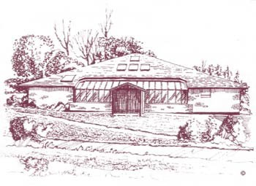
COMPLAINT FORM

Patient's Full Name:

Date of Birth:

Address:

Complaint details: (Include dates,time(s) and name of practice personnel, if known)

SIGNED………………………….PRINT NAME………………………DATE………..

